NAME: M. Mukesh Balaji
REG NO : 192412156
COURSE CODE : ITA0613
EXPERIMENT NO: 7
IMPLEMENTATION OF LOGISTIC REGRESSION ALGORITHM
Aim
To implement the Logistic Regression algorithm in Python for classifying data and predicting the target class using an appropriate dataset.
Procedure
- Import the required Python libraries.
- Load the dataset and preprocess the data.
- Split the dataset into training and testing sets.
- Create and train the Logistic Regression model using the training dataset.
- Predict the class labels for the testing dataset.
- Compare the predicted labels with the actual labels.
- Evaluate the model using suitable performance metrics such as accuracy.
- Display the predicted results.
- Analyze the performance of the Logistic Regression model.
- Interpret the classification results.
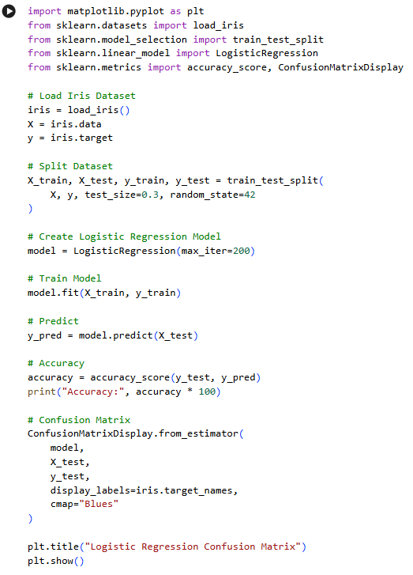
INPUT

OUTPUT
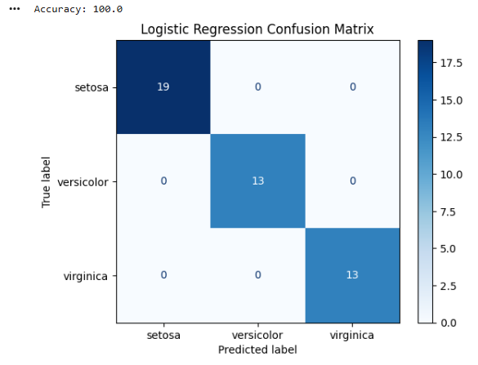

EXPERIMENT NO: 8
IMPLEMENTATION OF LINEAR REGRESSION ALGORITHM
Aim
To implement the Linear Regression algorithm in Python for predicting continuous values using an appropriate dataset.
Procedure
- Import the required Python libraries.
- Load the dataset and preprocess the data.
- Separate the input features and target variable.
- Split the dataset into training and testing sets.
- Create and train the Linear Regression model using the training data.
- Predict the target values for the testing dataset.
- Compare the predicted values with the actual values.
- Evaluate the performance of the model using suitable metrics such as Mean Squared Error (MSE) and R² score.
- Display the predicted results.
- Interpret the performance of the Linear Regression model.
INPUT
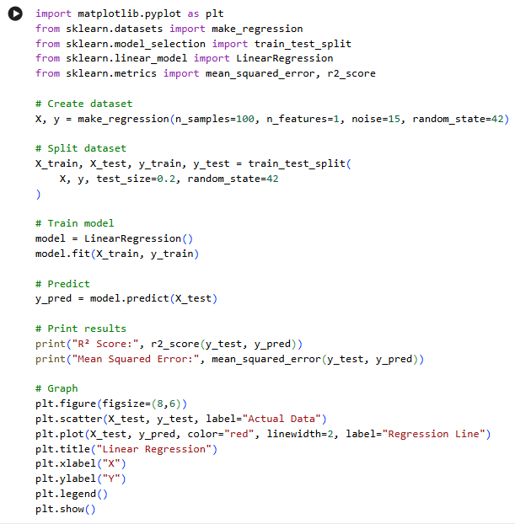

OUTPUT
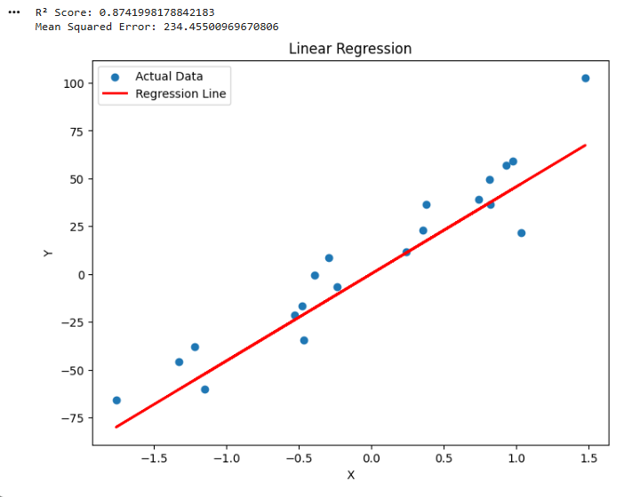

EXPERIMENT NO. 9
Comparison of Linear and Polynomial Regression using Python
AIM
To implement and compare Linear Regression and Polynomial Regression models using Python and evaluate their performance.
PROCEDURE
- Import the required Python libraries.
- Create a sample dataset containing input and output values.
- Split the dataset into training and testing data.
- Train a Linear Regression model.
- Transform the input data into polynomial features.
- Train a Polynomial Regression model.
- Predict the output using both models.
- Calculate the Mean Squared Error and R² score.
- Compare the performance of both models.
- Plot the actual data and regression curves.
INPUT
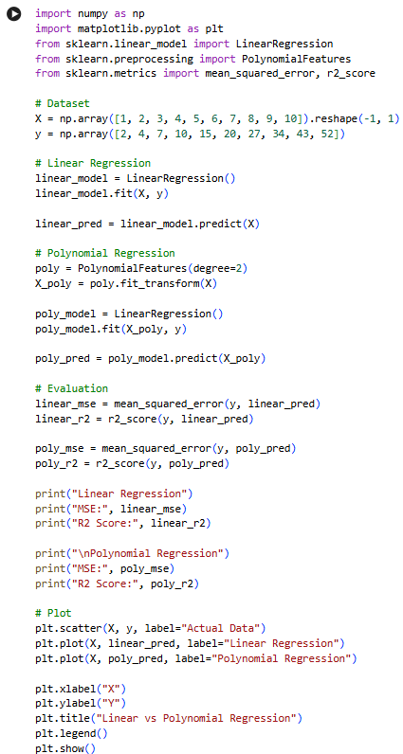
OUTPUT
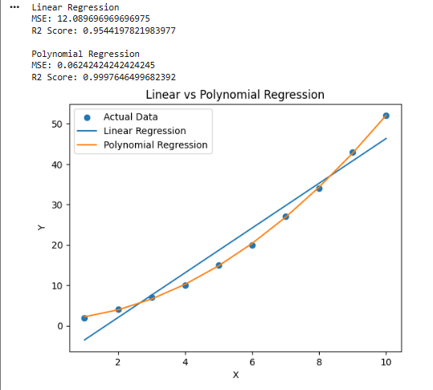
RESULT
Thus, Linear Regression and Polynomial Regression were successfully implemented and their performances were compared using MSE and R² score.
EXPERIMENT NO. 10
Implementation of Expectation-Maximization Algorithm
AIM
To implement the Expectation-Maximization (EM) algorithm in Python for clustering data into groups.
PROCEDURE
- Import the required libraries.
- Generate a sample dataset.
- Apply the Gaussian Mixture Model, which uses the EM algorithm.
- Specify the number of clusters.
- Train the model using the EM algorithm.
- Predict the cluster assigned to each data point.
- Display the clustered data graphically.
INPUT
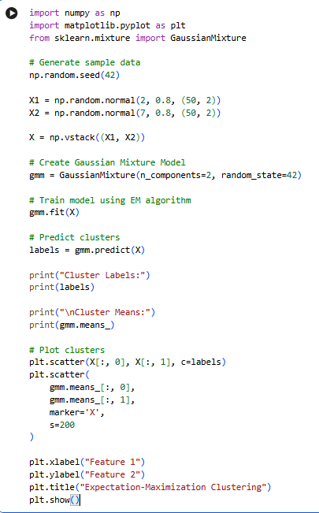
OUTPUT
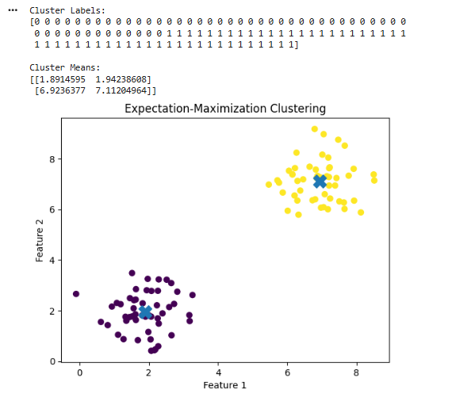
RESULT
Thus, the Expectation-Maximization algorithm was successfully implemented using a Gaussian Mixture Model and the data points were grouped into clusters.

EXPERIMENT NO. 11
Credit Score Classification
AIM
To build a machine learning model for classifying customers based on their credit-related information.
PROCEDURE
- Import the required libraries.
- Create a sample credit dataset.
- Separate the features and target variable.
- Split the dataset into training and testing sets.
- Train a classification model.
- Predict the credit category of the test data.
- Calculate the accuracy.
- Display the classification results.
INPUT
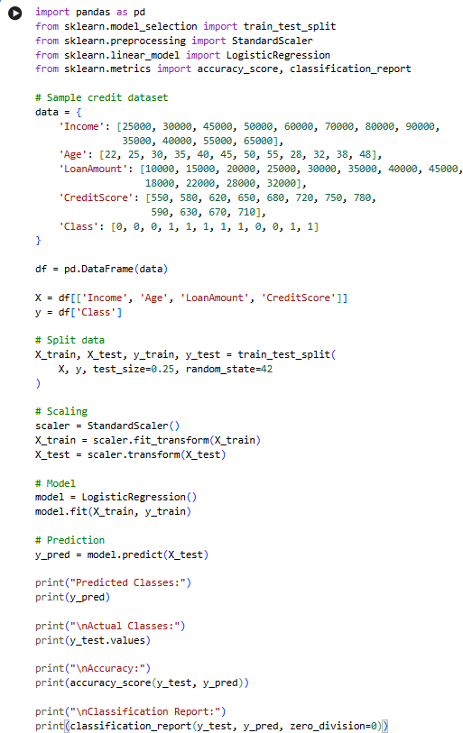
OUTPUT
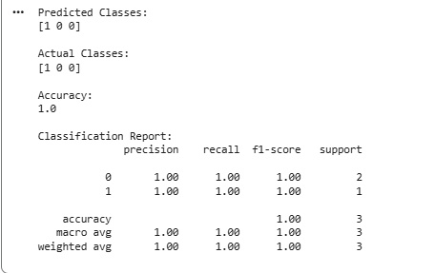
RESULT
Thus, the Credit Score Classification model was successfully implemented using Logistic Regression and its classification accuracy was obtained.

EXPERIMENT NO. 12
Iris Flower Classification using KNN
AIM
To implement the K-Nearest Neighbours algorithm for classifying Iris flowers based on their features.
PROCEDURE
- Import the Iris dataset.
- Separate the features and target values.
- Split the dataset into training and testing data.
- Create a KNN classifier.
- Train the classifier.
- Predict the flower classes for test data.
- Calculate the classification accuracy.
- Display the results.
INPUT
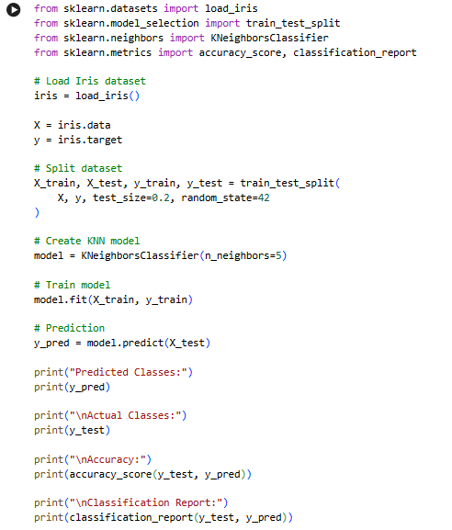
OUTPUT
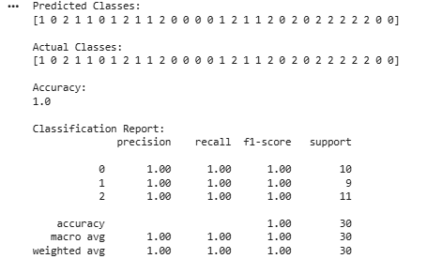
RESULT
Thus, Iris flower classification was successfully performed using the K-Nearest Neighbours algorithm

EXPERIMENT NO. 13
Car Price Prediction Model using Python
AIM
To develop a machine learning model for predicting car prices based on car features.
PROCEDURE
- Import the required libraries.
- Create a sample car dataset.
- Select the input features and target price.
- Split the dataset into training and testing data.
- Train a Linear Regression model.
- Predict car prices for the test data.
- Calculate the model performance.
- Display the predicted prices.
INPUT
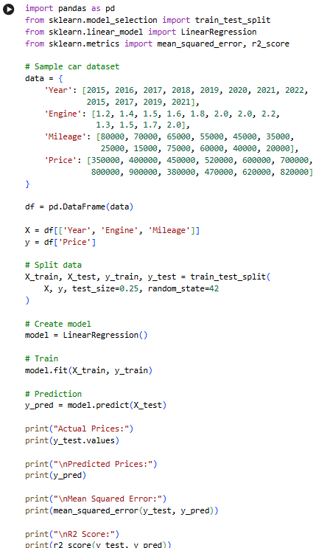
OUTPUT
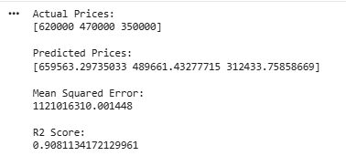
RESULT
Thus, the Car Price Prediction model was successfully implemented using Linear Regression.

EXPERIMENT NO. 14
House Price Prediction using Machine Learning
AIM
To develop a machine learning model for predicting house prices based on different house features.
PROCEDURE
- Import the required libraries.
- Create a sample house price dataset.
- Select suitable input features.
- Split the dataset into training and testing sets.
- Train a Linear Regression model.
- Predict house prices.
- Calculate MSE and R² score.
- Display the results.
INPUT
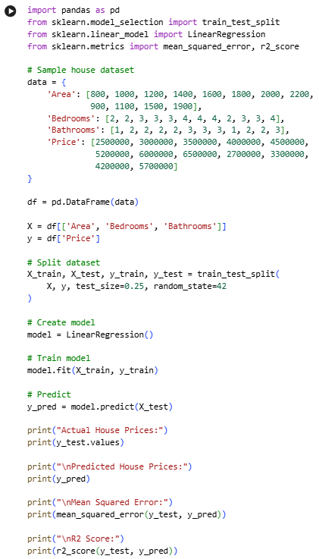
OUTPUT
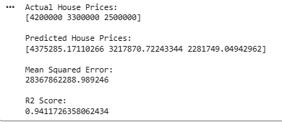
RESULT
Thus, the House Price Prediction model was successfully implemented using Linear Regression.

EXPERIMENT NO. 15
Iris Flower Classification using Naïve Bayes Classifier
AIM
To implement the Naïve Bayes classification algorithm for classifying Iris flowers.
PROCEDURE
- Load the Iris dataset.
- Separate features and target values.
- Divide the dataset into training and testing sets.
- Create a Gaussian Naïve Bayes classifier.
- Train the classifier.
- Predict the classes of test samples.
- Calculate the accuracy.
- Display the classification results.
INPUT
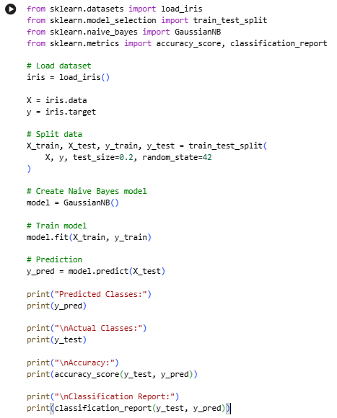
OUTPUT
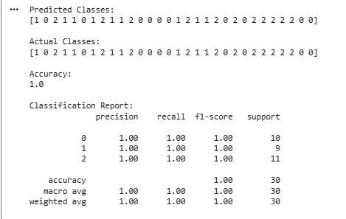
RESULT
Thus, Iris flower classification was successfully implemented using the Gaussian Naïve Bayes classifier.

EXPERIMENT NO. 16
Comparison of Different Classification Algorithms
AIM
To compare different classification algorithms and evaluate their performance using accuracy.
PROCEDURE
- Load the Iris dataset.
- Divide the dataset into training and testing sets.
- Implement Logistic Regression, KNN, Decision Tree and Naïve Bayes classifiers.
- Train each classifier using the training data.
- Predict the test data.
- Calculate the accuracy of each classifier.
- Compare the accuracy values.
INPUT
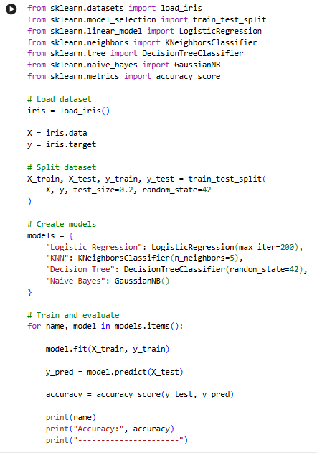
OUTPUT
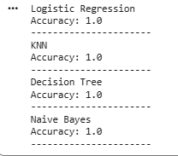
RESULT
Thus, different classification algorithms were successfully implemented and their performances were compared using classification accuracy.

EXPERIMENT NO. 17
Mobile Price Prediction using Machine Learning
AIM
To develop a machine learning model to predict the price category of mobile phones based on their features.
PROCEDURE
- Import the required libraries.
- Create a mobile phone dataset.
- Separate features and target values.
- Split the dataset into training and testing sets.
- Train a Random Forest classification model.
- Predict the mobile price category.
- Calculate the accuracy.
- Display the results.
INPUT
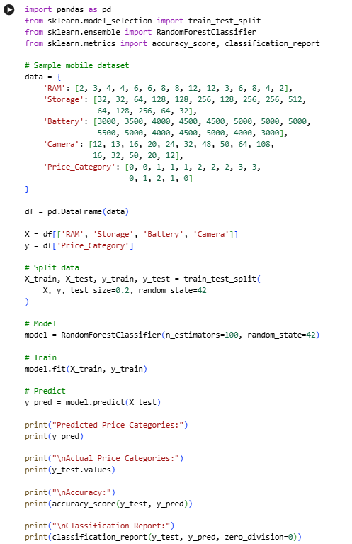
OUTPUT
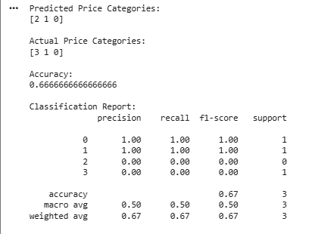
RESULT
Thus, the Mobile Price Prediction model was successfully implemented using a Random Forest classifier.

EXPERIMENT NO. 18
Perceptron Based IRIS Classification
AIM
To implement a Perceptron-based machine learning model for Iris flower classification.
PROCEDURE
- Load the Iris dataset.
- Select two classes from the Iris dataset.
- Divide the data into training and testing sets.
- Create a Perceptron classifier.
- Train the model.
- Predict the classes of test samples.
- Calculate the accuracy.
- Display the results.
INPUT
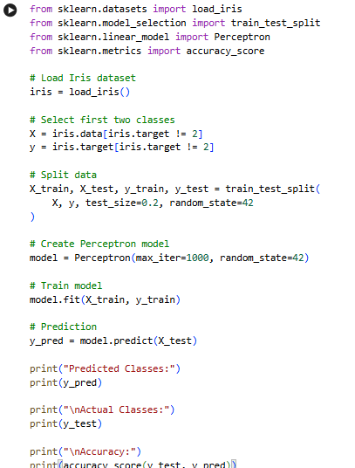
OUTPUT
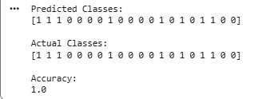
RESULT
Thus, Iris classification using the Perceptron algorithm was successfully implemented and its accuracy was calculated.

EXPERIMENT NO. 19
Naïve Bayes Classification for Bank Loan Prediction
AIM
To implement the Naïve Bayes classification algorithm for predicting whether a bank loan will be approved.
PROCEDURE
- Create a sample bank loan dataset.
- Select the relevant features.
- Divide the dataset into training and testing data.
- Create a Gaussian Naïve Bayes classifier.
- Train the classifier.
- Predict loan approval for test data.
- Calculate the accuracy.
- Display the prediction results.
INPUT
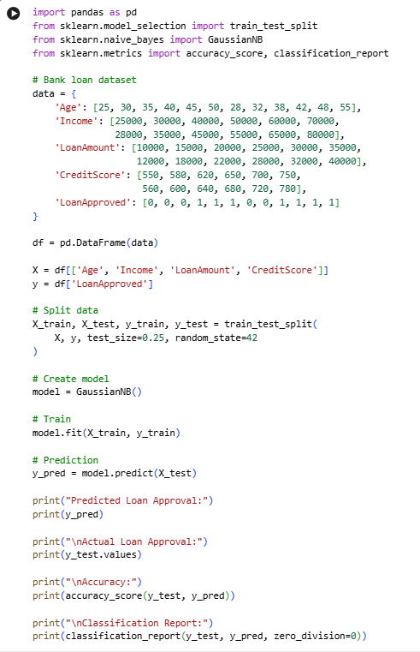
OUTPUT
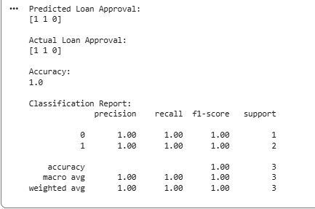
RESULT
Thus, the Naïve Bayes classification algorithm was successfully implemented for bank loan prediction.

EXPERIMENT NO. 20
Future Sales Prediction using a Suitable Machine Learning Algorithm
AIM
To develop a machine learning model for predicting future sales using historical sales data.
PROCEDURE
- Create a historical sales dataset.
- Prepare the input and target variables.
- Split the data into training and testing sets.
- Train a Linear Regression model.
- Predict future sales.
- Calculate the prediction error.
- Display the predicted sales values.
- Plot the actual and predicted sales.
INPUT
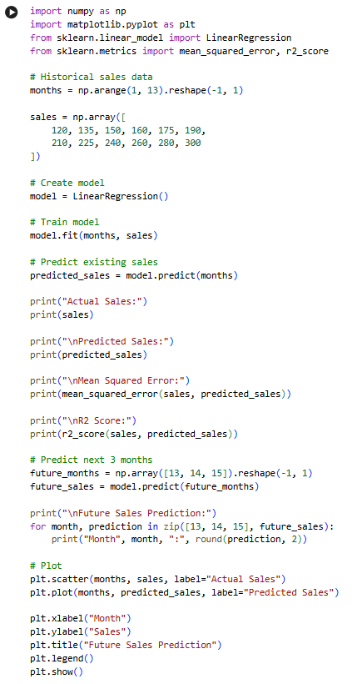
OUTPUT
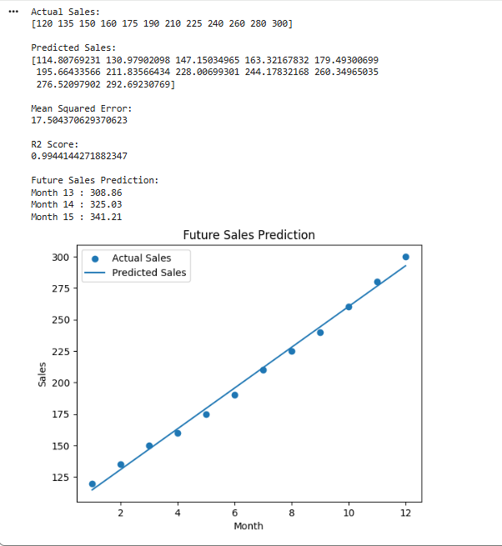
RESULT
Thus, the Future Sales Prediction model was successfully implemented using Linear Regression, and future sales values were predicted.

